SECTION 1 — GENERAL

1.1 Module Introduction
The Components Sub Module forms the foundational equipment register of the PMS.
It contains the full hierarchical structure of all machinery, equipment, and systems onboard a vessel, organized strictly as per SFI Codes.
This module serves as the master reference for the entire PMS and directly drives:
- Job scheduling
- Work Order generation
- Running Hours tracking
- Spare parts association
- Equipment documentation
- Class & statutory requirements
- PMS modifications
- Vessel-specific maintenance history
All other modules—such as Running Hours, Work Orders, Spares, Modify PMS, Reports—depend on the data stored and maintained here.

1.2 Purpose of This Module
This module is designed to:
- Provide a complete and accurate component hierarchy of a vessel using SFI classification.
- Store equipment-specific technical details, including Maker, Model, Serial No., Installation Date, and Criticality.
- Maintain a consistent Fleet Equipment Code (FEC) that standardizes equipment across vessels using the same model.
- Link all maintenance jobs, frequencies, and scheduling logic to the correct component.
- Serve as the main location where users view:
  - Component Information
  - Running Hours
  - Jobs
  - Maintenance History
  - Spares
  - Manuals & Drawings
  - Classification & Regulatory Data
- Provide controlled pathways for modifications through the Modify PMS module.
- Ensure all component data remains accurate, consistent, traceable, and vessel-specific.

1.3 Key Design Principles
- Strict SFI Structure
  - The complete hierarchy is strictly based on SFI codes.
  - Top-level SFI groups (1–8) cannot be changed.
- Consistent Fleet Equipment Code
  - FEC is generated based on Maker Code + Model Code.
  - Typically 10 characters (but not a strict limit).
  - Assigned only by the PMS software provider.
- Vessel-Specific Implementation
  - Each vessel has its own component register.
  - Same FEC across vessels; Component Codes differ per vessel.
- Traceability & Safety
  - All maintenance history is immutable.
  - Running Hours changes are delta-based and fully logged.
  - Criticality is controlled by company technical staff.
- Controlled Editing
  - Ship staff cannot modify component structure directly.
  - All structural changes go through Modify PMS for approval.

1.4 Module Dependencies (Functional Relationships)
The Components Module interacts with:
1. Running Hours Module
- Tracks current RH for parent components.
- Delta RH updates propagate to all child components.
- RH-based jobs depend entirely on RH module values.
2. Work Orders Module
- Calendar-based and RH-based jobs originate from Components.
- Work Orders feed Maintenance History in this module.
3. Spares Module
- Vessel-specific spares linked to each component appear in Section E.
- Fleet/company spares templates are not shown here.
4. Modify PMS Module
- Ship proposes changes (jobs, frequency, components, details).
- Office approves → changes reflect in Components Module.
5. Admin Module
Used for:
- Excel uploads of Component Registers
- Job Templates
- Spare Masters
- Maker/Model Masters
- Document Types
- Class Survey Templates
- Running Hours lead-time settings
6. Document Library
- Central storage for manuals, drawings, and regulatory files.
- Ship users get view-only access.

1.5 User Personas
1. PMS Software Provider (Admin)
- Full access to add/edit/delete fields, labels, templates.
- Upload complete PMS structures via Excel.
- Modify SFI hierarchy if needed (top-level groups remain fixed).
2. Company Superintendent / Technical Office
- Assigns Criticality.
- Enters Class/Regulatory details.
- Reviews & approves PMS modification requests.
- Controls job templates and vessel-specific customizations.
3. Ship Staff
- Can view the full Equipment Register.
- Can update Running Hours (through RH module).
- Can view all linked jobs, spares, manuals, and history.
- Cannot modify component details directly.
- Can only propose changes through Modify PMS.
4. Auditors / Class Surveyors
- View-only access for compliance and inspection purposes.

1.6 SFI Code Framework in PMS
The PMS uses the SFI Classification System for equipment breakdown.
Main Groups (Fixed)
1 – Ship General
2 – Hull
3 – Equipment for Cargo
4 – Ship’s Equipment
5 – Equipment for Crew & Passengers
6 – Machinery Main Components
7 – Systems for Machinery Main Components
8 – Ship Common Systems

1.7 Fleet Equipment Code (FEC)
A unique ID assigned by PMS Software Provider.
Key Points
- Typically 10 characters (not strictly enforced).
- Generated from Maker Code + Model Code.
- Identifies equipment type across the entire fleet.
- Used to link:
  - Jobs
  - Spares
  - Manuals
  - Templates
FEC cannot be modified by ship or company.

1.8 Component Criticality
Critical/Non-critical is assigned by the company superintendent.
Impact of Critical = YES
- Component appears in Critical filter.
- Jobs attached to component inherit critical status.
- Critical spares can be linked under Section E.
- Reports classify equipment as critical.

1.9 Running Hours Framework
Parent → Child Propagation (Delta Logic)
- RH entered in RH Module for parents.
- PMS calculates change (delta).
- Delta is added automatically to all child components.
- If child component was replaced → RH starts from zero, then delta added.
Logging
- Every RH update must be recorded with:
  - Timestamp
  - User
  - Delta value
  - New RH value
Editable here via pencil icon, but still logged.

1.10 Maintenance Job Logic
Sources of Jobs
- Admin Excel upload
- SFI-based job grouping
- Manual “Add Job” (office only)
Job Types
- Calendar-based
- Running-Hour based
Work Order Generation Rules
- Calendar jobs → based on date intervals
- RH jobs → based on Delta RH
- Lead-time is configurable in Admin module
- Ship staff cannot edit job details here

1.11 Manuals, Drawings & Documentation
- Central repository
- Uploaded by company or PMS admin
- Ship can view only with embedded PDF viewer
- Office can download files
- Multiple files may exist per component

1.12 Class & Regulatory Requirements
- Multiple survey rows allowed per component
- Supports Annual, Intermediate, Special, Damage Surveys
- Certificate No., Survey Type, Dates captured
- Can be uploaded by Excel or entered manually
- Office can update, ship cannot edit

1.13 Requisitions (Future Integration)
- Placeholder section
- Pane collapsed by default
- No user actions required
- Will connect to Purchase module in future

SECTION 2 – UI STRUCTURE (COMPONENTS MODULE)
This section defines how the Components screen is laid out visually and how the main UI elements behave. It is written to be used directly as a UI/functional spec for PMS.

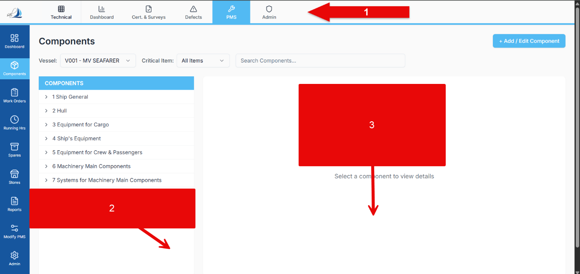

2.1 Overall Screen Layout
When the user clicks on PMS → Components in the top bar, the Components screen opens.
The screen is divided into three main zones:
- Top Navigation Bar (common across PMS)
- Left Navigation Sidebar (module navigation)
- Main Content Area
  - Top Filter Bar
  - Left Component Tree Pane
  - Right Component Details Pane
The layout is two-column in the main content area:
- Left column: Component Tree (SFI-based equipment hierarchy).
- Right column: Component details (Sections A–H) or “Select a component to view details” empty state.

2.2 Top Navigation Bar
The top navigation bar is common for all PMS technical modules and appears above the Components screen.

2.2.1 Items
From left to right (as per screenshot):
- Technical
- Dashboard
- Cert. & Surveys
- Defects
- PMS (highlighted when Components module is active)
- Admin

2.2.2 Behaviour
- Clicking PMS keeps user within PMS modules; Components is one of them.
- The highlight (blue background) indicates the current top-level tab.
- Switching to another tab (e.g. Dashboard, Defects) navigates away from Components and loads that module’s screen.
(No additional assumptions are made here about routing or state preservation.)

2.3 Left Navigation Sidebar (Module-Level)
A vertical blue sidebar is present on the extreme left. It holds icons for the main PMS modules.

2.3.1 Icons (top to bottom)
- Dashboard
- Components (highlighted when in this screen)
- Work Orders
- Running Hrs
- Spares
- Stores
- Reports
- Modify PMS
- Admin

2.3.2 Behaviour
- Clicking an icon switches module while staying inside PMS context.
- Components icon is highlighted (different background/indicator) when this screen is active.
- Behaviour of other module icons is defined in their respective module specs.

2.4 Main Content Area – High Level
Inside the white area to the right of the blue sidebar:
- A page title:
  - Components
- A filter bar directly below the title (Vessel / Critical Item / Search).
- A two-column layout:
  - Left: Component Tree
  - Right: Component Detail Panel
When no component is selected, the right panel shows a centered text:
“Select a component to view details”
When a component is selected, the right panel shows Sections A–H (Component Information, Running Hours, Jobs, etc.) in stacked, collapsible cards.

2.5 Filter Bar (Top of Components Screen)
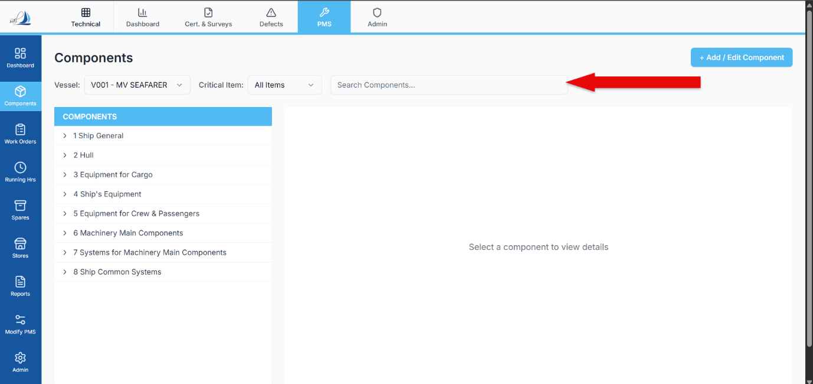
The filter bar sits below the “Components” heading and above the tree/detail columns.

2.5.1 Elements
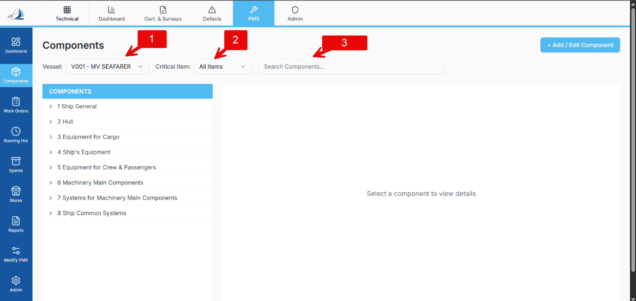
From left to right:
- Vessel Dropdown
  - Label shown as Vessel:
  - Current selection sample: V001 – MV SEAFARER
  - Dropdown options as seen in screenshot:
    - V001 – MV SEAFARER
    - V002 – MV VOYAGER
    - V003 – MV EXPLORER
- Critical Item Filter
  - Label: Critical Item:
  - Dropdown currently showing All Items
  - As per your latest instruction, this should eventually become a tick box (e.g., “Critical only”), but in the current UI we keep it as dropdown until changed.
- Search Box
  - Placeholder: Search Components...
  - Single-line text input.
- Add / Edit Component Button (aligned to the right edge of the screen)
  - Blue button: + Add / Edit Component

2.5.2 Behaviour
(a) Vessel Dropdown
- Selecting a vessel from this dropdown:
  - Reloads the entire component tree in the left pane for the selected vessel.
  - Reloads the right pane with:
    - A blank state (Select a component to view details) until a component is picked.
  - All data displayed (jobs, spares, history, manuals, class data) is always for the currently selected vessel.
(b) Critical Item Filter
- Current design shows a dropdown with at least:
  - All Items
  - Critical Items (for critical components only)
- When Critical Items is active:
  - Component tree should show only components marked as Critical = Yes, or highlight/filter accordingly (exact tree behaviour can be detailed later if you wish).
- You have suggested that this may later become a tickbox (“Critical”) instead of dropdown; this will be handled when UI is updated.
(c) Search Box – Smart Search
- User can type free text.
- Search must be smart and search across at least:
  - Component Name
  - SFI / Component Code
  - Fleet Equipment Code (if displayed anywhere in tree)
  - Maker
  - Serial Number
- Matching components:
  - Are highlighted in the component tree, OR
  - The tree auto-scrolls to and expands the branch where the match exists (exact visual behaviour can be defined later, but logic is: locate components by any of these keys).
(d) Add / Edit Component Button
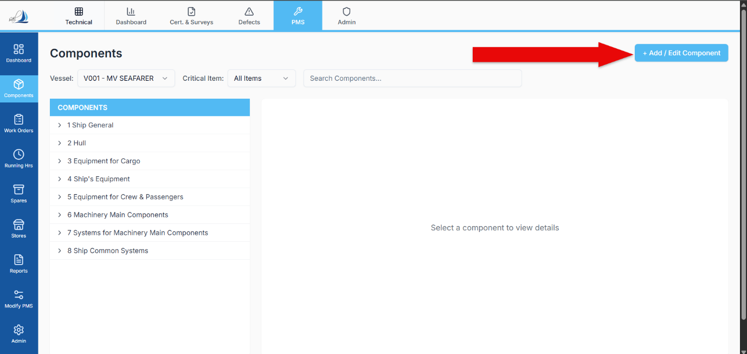
- Behaviour depends on user role (detailed later in role section, but UI behaviour here):
  - When clicked, opens a Component Master Form for the position in the tree that is currently selected.
  - If no node is selected, system may prompt user to select where to add (tree behaviour defined in next sections).
  - The form contains sections A–H with empty fields (for new component) or prefilled fields (for editing), respecting permissions:
    - Ship users: can fill data for new components but changes go through Modify PMS workflow for approval before they appear in live tree.
    - Software provider and office admin: can commit changes directly.
(Detailed approval logic will come in later sections.)

2.6 Left Pane – Component Tree
The left pane has a blue header bar with label:
- COMPONENTS (all caps, white text on blue background)
Below that, a vertical tree grid is shown.

2.6.1 Top-level Nodes
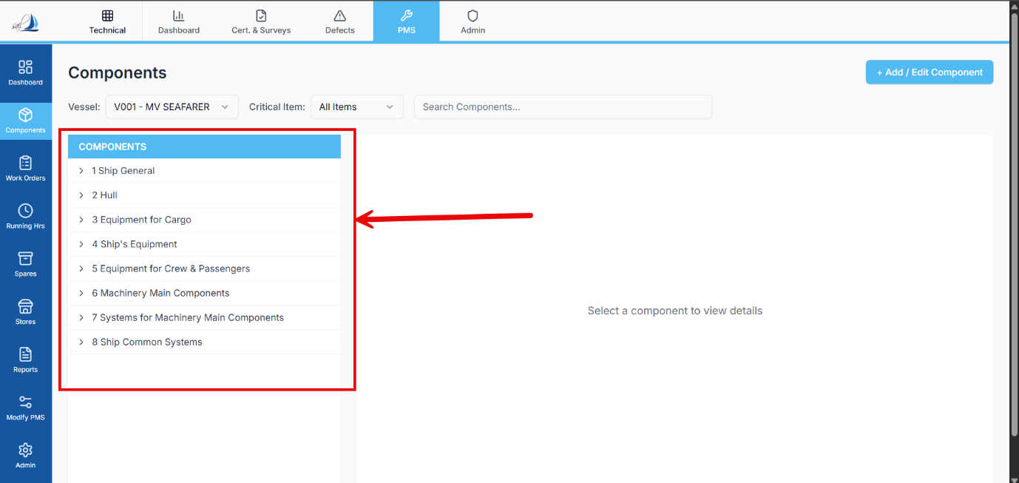
As per SFI groups shown in screenshot:
- 1 Ship General
- 2 Hull
- 3 Equipment for Cargo
- 4 Ship's Equipment
- 5 Equipment for Crew & Passengers
- 6 Machinery Main Components
- 7 Systems for Machinery Main Components
- 8 Ship Common Systems
Each top-level row has:
- A disclosure arrow (> / caret) on the left for expand/collapse.
- When a node is selected, its background becomes light blue.

2.6.2 Sub-level Nodes
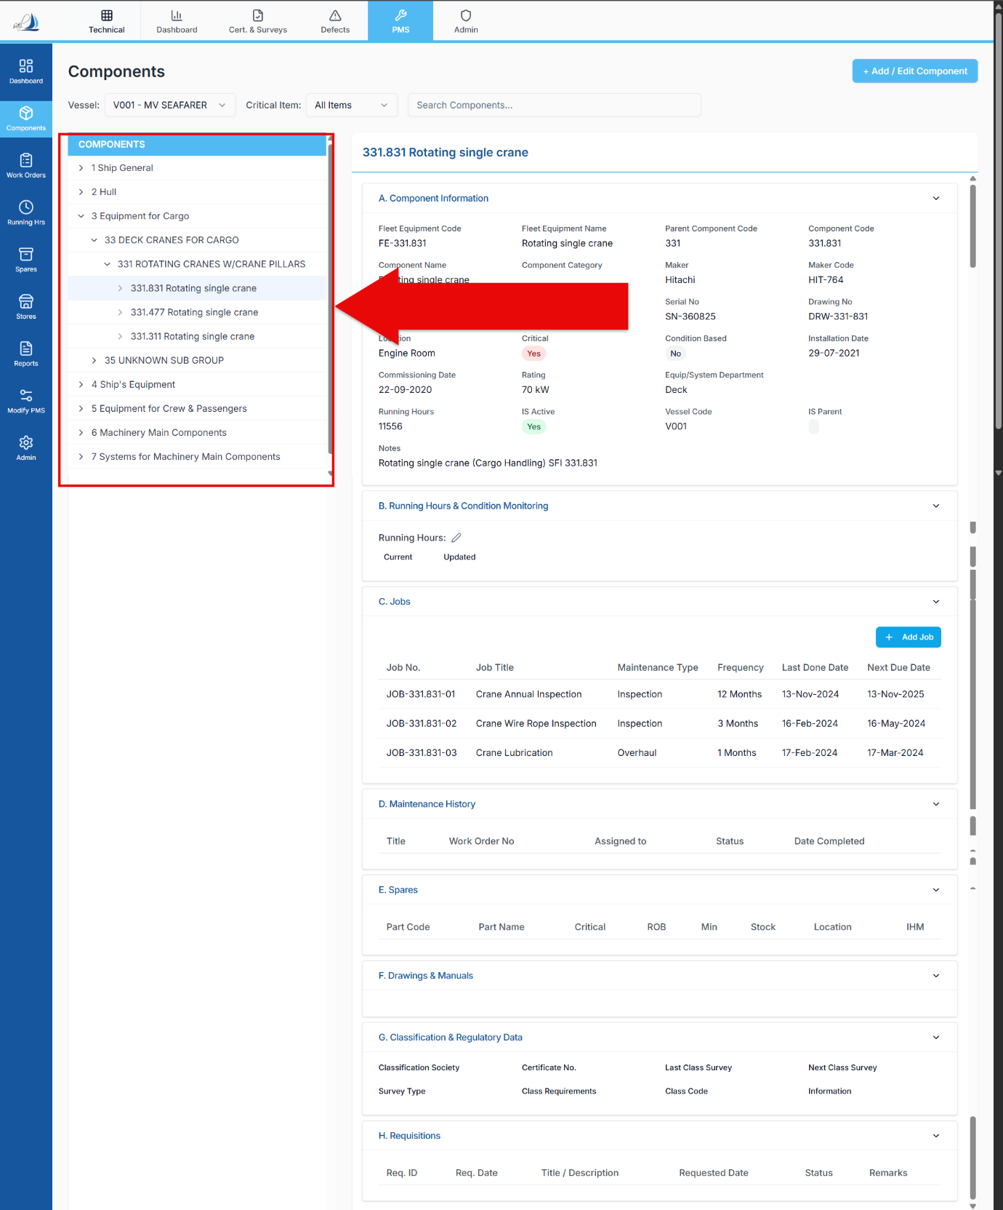
Example shown:
- 3 Equipment for Cargo
  - 33 DECK CRANES FOR CARGO
    - 331 ROTATING CRANES W/CRANE PILLARS
      - 331.831 Rotating single crane
      - 331.847 Rotating single crane
      - etc.
Characteristics:
- Hierarchical indentation for each child level.
- Each child node also has a disclosure arrow if it contains further children.
- The selected leaf-level component (e.g., 331.831 Rotating single crane) is highlighted.

2.6.3 Behaviour
- Clicking a row:
  - Sets it as selected.
  - Loads component details in right pane if the node represents an actual equipment/component (not just a grouping).
- The tree is always filtered to the currently selected vessel from the filter bar.
- No “hidden components” concept – all valid nodes are visible.

2.6.4 Adding Components via Tree

When “+ Add / Edit Component” is clicked while a node is selected:
- If the selected node is a 3-digit SFI group (e.g. 331):
  - System calculates the next available 3-digit code at that level (e.g. 332, 333), following the existing SFI structure for that vessel.
- If the selected node is a deeper sub-code (e.g. 331.831):
  - System calculates the next available child code under that node (e.g. 331.832, 331.833 etc., or equivalent per SFI rules).
- No dashes are allowed; only digits and dots, following whatever codes are already present from the Admin-uploaded Excel.
Actual persistence and approval will be defined under Modify PMS / Admin sections later.

2.7 Right Pane – Empty State
When the screen loads or when the user has not yet selected a component:
- The right pane displays a centered message:
“Select a component to view details”
- No sections (A–H) are visible in this state.
- Once a component is selected in the tree, this message disappears and the Component Detail Layout is shown.

2.8 Right Pane – Detail State (High Level)
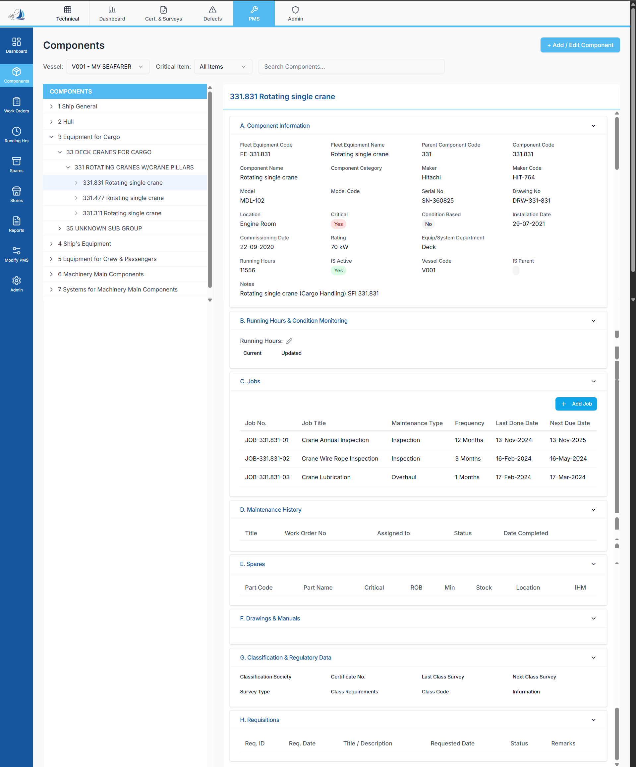
When a component (leaf node or equipment node) is selected in the tree:
- The right pane is filled with a vertical stack of collapsible panels, representing Sections A to H:
  - A. Component Information
  - B. Running Hours & Condition Monitoring
  - C. Jobs
  - D. Maintenance History
  - E. Spares
  - F. Drawings & Manuals
  - G. Classification & Regulatory Data
  - H. Requisitions
- Each section has:
  - A header bar (with section letter and title).
  - Content area under it (tables and fields).
  - Collapse/expand icon (chevron) on right.

2.8.1 Collapsing Behaviour
- Sections can be collapsed individually.
- Even when collapsed, at least a small preview row or two may remain visible (especially for list sections like Jobs and Spares) so that the user can identify which section holds what without too much expanding/collapsing.
- Section H (Requisitions) is currently collapsed by default and acts as a placeholder for future purchase integration.
(Exact section-by-section contents and field behaviours will be defined in later sections A–H.)

2.9 Scroll Behaviour
Because the right pane contains multiple sections and potentially large tables:
- The right pane is vertically scrollable.
- The top filter bar and left component tree remain fixed in place when scrolling, so the user does not lose context of the selected vessel and component.

2.10 Responsive Behaviour (High-Level)
From the screenshots, the design is optimized for desktop usage:
- Two-column layout is maintained.
- Tables and forms are wide, suggesting a minimum horizontal resolution.
If mobile or tablet behaviour is needed, that can be separately specified; for now, this spec focuses on the desktop/web app layout as in the screenshots.

SECTION 3 — A. COMPONENT INFORMATION
This is the primary information block for every equipment item in the PMS and is displayed as Section A when a component is selected in the component tree.
It is the first and most critical section, as all other sections (Running Hours, Jobs, Spares, Manuals, Class, History) depend on the data stored here.
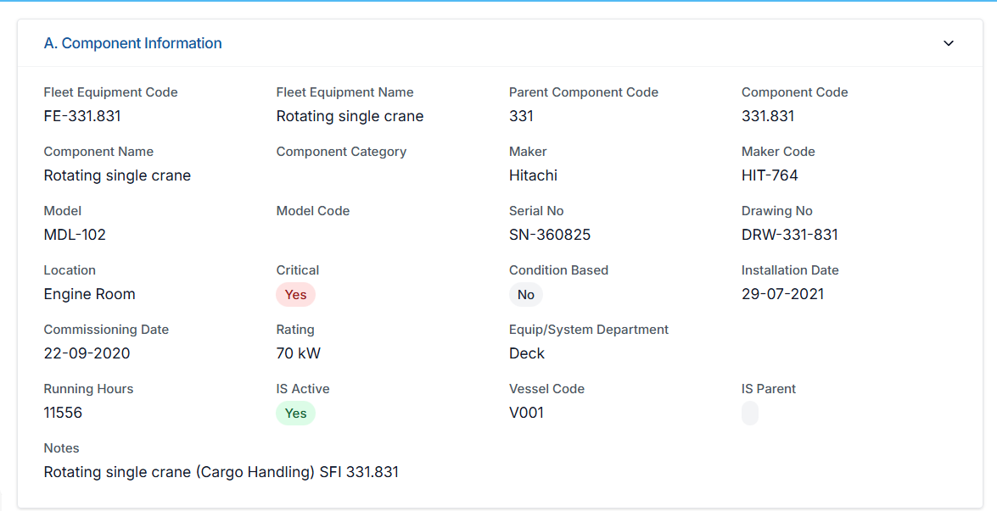

3.1 Section Layout
- Displayed as a collapsible card titled:
A. Component Information
- Always expanded by default when a component is selected.
- Information is presented in a multi-column grid with labelled fields.
- Fields are grouped logically (Maker/Model details, Codes, Dates, Flags, Notes).

3.2 Fields & Behaviour (Field-by-Field Logic)
Below is a complete list of all fields exactly as seen in your screenshot, with their correct meanings, permissions, data sources, and behaviour.

A. IDENTIFICATION FIELDS

1. Fleet Equipment Code
Purpose
A unique fleet-wide identifier for this equipment type.
Logic
- Assigned only by PMS Software Provider.
- Typically 10 characters (e.g., “601.001.AA”), but no strict limit enforced.
- Generated based on Maker Code + Model Code.
- All vessels using the same equipment model share this Fleet Equipment Code.
Editable by:
- Software Provider only
- Ship users → NO
- Company office → NO
Source:
- Entered via Admin Excel upload
- Or via PMS Admin interface when creating equipment master

2. Fleet Equipment Name
Purpose
The common fleet-wide name associated with the Fleet Equipment Code.
Logic:
- Same name across fleet for same equipment type
- Ensures consistency in jobs, spares, manuals
Editable by:
- Software Provider only
- Not editable by ship/company

3. Parent Component Code
Purpose
Defines the SFI-based parent of this component to maintain the hierarchical navigation structure.
Logic:
- Reflects the SFI grouping above this item
- Determines where it appears in the component tree
- Also determines code auto-generation path for new subcomponents
Editable by:
- Software Provider
- Office (in Admin PMS editor)
- Ship → NO (ship can request change via Modify PMS)
Source:
- From Admin Excel upload
- Or auto-generated by system when adding new components under a node

4. Component Code
Purpose:
The SFI-based code for this component on this specific vessel.
Logic:
- Strictly digits + dots (no dashes)
- Follows SFI structure uploaded by Admin
- When adding new subcomponents:
  - Under 331 → next 3-digit: 332, 333, etc.
  - Under 331.831 → next child: 331.832, 331.833, etc.
Editable by:
- Software Provider (Admin) only
- Office cannot change code after creation
- Ship cannot change
Generated by:
- System automatically when added under a selected SFI node

5. Component Name
Purpose:
Human-readable name of the equipment.
Logic:
- Vessel-specific name
- Should be clear and descriptive (e.g., “Rotating single crane”)
Editable by:
- Office (in Admin or Modify PMS approval stage)
- Software Provider
- Ship cannot edit here

6. Component Category
Purpose:
Internal classification to group components by functional type.
Examples:
- Ship's Structure
- Deck Machinery
- Engine Department
- Safety Equipment
- Accommodation
- Hull
- Equipment for Cargo
- Ship General
Editable by:
- Software Provider
- Office (Admin)
- Ship → cannot change

B. MAKER & MODEL FIELDS

7. Maker
Purpose:
Manufacturer of the equipment.
Editable by:
- Office
- Software Provider
- Not editable by ship
Source:
- From Admin Excel template
- Can be selected from Maker master list

8. Maker Code
Purpose:
Short code for the manufacturer, used internally for Fleet Equipment Code generation.
Editable by:
- Software Provider only
- Ship/Office cannot change

9. Model
Purpose:
Model name/number of equipment.
Editable by:
- Office
- Software Provider
- Ship cannot edit

10. Model Code
Purpose:
Short code representing the model, used in Fleet Equipment Code.
Editable by:
- Software Provider only

11. Serial Number
Purpose:
Unique serial number printed on the equipment.
Editable by:
- Office
- Ship → NO
- Software Provider → YES
Source:
- From Admin Excel upload or manually entered by office

12. Drawing Number
Purpose:
Reference number for the equipment drawing/manual.
Editable by:
- Office
- Software Provider
- Ship cannot edit

C. PHYSICAL DETAILS & ATTRIBUTES

13. Location
Purpose:
Physical location onboard the vessel where the equipment is installed.
Editable by:
- Office
- Software Provider
Examples:
- Engine Room
- Deck
- Steering Gear Room
- Pump Room

14. Critical (Yes/No)
Purpose:
Indicates whether this equipment is considered critical by the company.
Editable by:
- Company Superintendent / Technical Office
- Ship → NO
- Software Provider → YES
Impact:
- Job criticality
- Spare criticality
- Critical Items filter
- Reports

15. Condition Based (Yes/No)
Purpose:
Reserved for future condition-based maintenance implementation.
Current Behaviour:
- Always “No” in PMS
- Does NOT affect frequency or scheduling
- No CBM module implemented yet
Editable by:
- Office
- Software Provider

16. Commissioning Date
Purpose:
Date the equipment was commissioned on the vessel.
Logic:
- Used as fallback “Last Done Date” for jobs if no previous history exists
- Acts as baseline for new ships/components
Editable by:
- Office
- Software Provider
- Ship → NO

17. Rating
Purpose:
Any technical rating associated (e.g. “70 kW”, “20 bar”, etc.)
Editable by:
- Office
- Software Provider

18. Equip/System Department
Purpose:
Indicates which department owns the equipment.
Example values:
- Deck
- Engine
- Electrical
Editable by:
- Office
- Software Provider

19. Installation Date
Purpose:
Date equipment was physically installed onboard.
Editable:
- Office
- Software Provider
Used for:
- Determining new equipment
- Regulatory documentation
- Replacement events (via Modify PMS)

D. RUNNING HOURS FIELDS

20. Running Hours
Purpose:
Shows the current running hours for this component.
Displayed:
- Last saved RH from Running Hours module
- Propagates delta updates from parent component
Editable by:
- Ship can update via Running Hours Module, NOT here
- Pencil icon here opens quick RH update form but still logs timestamp + delta
Important:
- If parent RH increases by +N → all children get +N (delta logic)
- If child replaced → its RH resets to 0, but future deltas still apply

21. IS Active (Yes/No)
Purpose:
Indicates whether component is currently active or not.
Typical cases:
- Equipment decommissioned
- Equipment removed from service
- Temporarily disabled
Editable by:
- Office
- Software Provider
Ship cannot change.

22. Vessel Code
Purpose:
Identifies the vessel to which this specific component belongs.
Editable:
- Not editable by ship
- Automatically populated based on vessel selection
- Defined through Admin Excel upload

23. IS Parent (Checkbox)
Purpose:
Indicates whether this component is a parent node in the component tree.
Logic:
- If IS Parent = YES:
  - Component will show children in tree
  - RH propagation applies downward
- If IS Parent = NO:
  - Component has no children under it
  - Only receives deltas from above
Editable:
- Software Provider only
- Office/Ship cannot change parent flag

24. Notes (Multi-line field)
Purpose:
Free text notes associated with component.
Editable by:
- Office
- Software Provider
Ship cannot edit (unless proposed via Modify PMS).

3.3 Field Permissions Summary Table
Field | Ship | Office | Software Provider
Fleet Equipment Code | No | No | Yes
Fleet Equipment Name | No | No | Yes
Parent Component Code | No | Conditional (Admin only) | Yes
Component Code | No | No | Yes
Component Name | No | Yes (Admin/approval) | Yes
Maker / Maker Code | No | Maker: Yes, Code: No | Yes
Model / Model Code | No | Model: Yes, Code: No | Yes
Serial No | No | Yes | Yes
Drawing No | No | Yes | Yes
Location | No | Yes | Yes
Critical | No | Yes | Yes
Condition Based | No | Yes | Yes
Commissioning Date | No | Yes | Yes
Rating | No | Yes | Yes
Equip/System Dept | No | Yes | Yes
Installation Date | No | Yes | Yes
Running Hours | Only via RH Module | No direct edit | Yes
IS Active | No | Yes | Yes
Vessel Code | No | No | System
IS Parent | No | No | Yes
Notes | No | Yes | Yes

3.4 Behaviour on Component Selection
When a user selects a component in the tree:
- Section A loads immediately with all fields displayed in read-only mode.
- If user has permissions (office/admin), editable fields show pencil icons.
- Data shown is specific to selected vessel.
- Any change triggers:
  - Validation
  - Audit logging
  - Possibly Modify PMS workflow (if ship proposes changes)

3.5 Source of Data for Section A
- Initial PMS Upload (Excel in Admin module)
- PMS Admin Interface (software provider)
- Modify PMS Module (for ship to propose changes)
- Running Hours Module (for RH updates)
- Work Orders Module (affects maintenance history but not Section A fields)
- Manual entries by office (allowed fields only)

3.6 Dependency Notes
Section A acts as the backbone for:
- Section B (Running Hours)
Uses RH and parent-child relationships defined here.
- Section C (Jobs)
Jobs are linked using Component Code & Fleet Equipment Code.
- Section E (Spares)
Spares are mapped to Component Code.
- Section F (Drawings & Manuals)
Uses Maker, Model, Drawing No for file classification.
- Section G (Class & Regulatory)
Equipment type affects survey requirements.

SECTION 4 — B. RUNNING HOURS & CONDITION MONITORING
This is Section B in the Component Details screen. It appears directly below Section A and provides a summary of the running hours for the selected component, along with future provision for condition monitoring.
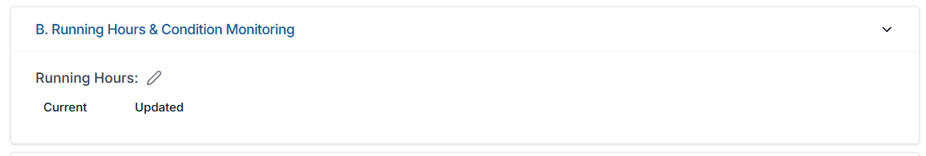

4.1 Section Layout
- Displayed as a collapsible panel labeled:
B. Running Hours & Condition Monitoring
- Expanded by default when a component is selected.
- Contains two main fields:
- Running Hours – Current
- Running Hours – Updated
- Pencil icon for editing running hours
(Condition Monitoring portion is reserved for future implementation but shown as part of the UI as per screenshot.)

4.2 Running Hours – Core Logic
Running Hours in PMS follow a strict parent–child structure:

4.2.1 Parent → Child Delta Rule (Mandatory Behaviour)
When the Running Hours of a parent component are updated (in Running Hours Module):
- System calculates:
Delta = New RH – Previous RH
- Delta value is applied to all child components, except those recently replaced.
Example:
Parent RH increases from 5000 → 5010
- Delta = +10
- All children RH get +10 added automatically:
  - Child 1: 2000 → 2010
  - Child 2: 0 → 10 (newly replaced component)
  - Child 3: 105 → 115
This propagation ensures correct scheduling for RH-based maintenance jobs.

4.2.2 Replacement Scenario
If a child component has been replaced (Running Hours reset to 0):
- After reset: RH = 0
- Next parent delta still applies normally
- New child RH = 0 + delta
This allows:
- Parent engine at 10,000 hrs
- New liner at 0 hrs
- But future running patterns still flow correctly
(This behaviour is essential for engines, compressors, pumps, hydraulic systems, rotating cranes etc.)

4.3 Running Hours Display Fields

1. Current
- Shows the latest running hours value of this component.
- Sourced from:
  - RH Module updates (ship input)
  - Parent delta propagation
  - New component replacement reset
Read-only in this screen (Section B).

2. Updated
- Shows the timestamp or date of last RH update.
- Ensures traceability.
- This field is read-only.

3. Pencil Icon (Quick Update)
Even though RH should be updated in Running Hours Module, PMS allows a quick update option here:
When user clicks the pencil icon:
- Opens a small RH edit modal
- User enters new RH
- The system:
  - Validates the value
  - Calculates delta
  - Applies delta to all children
  - Logs the update with timestamp
  - Sends change to Work Order system for RH-based job checks
Permissions:
- Ship users → Allowed to update
- Office → Allowed
- Software Provider → Allowed
- But all changes are logged (user, timestamp, delta)

4.4 Interaction With Running Hours Module
Running Hours Module is the primary point for RH input.
Section B:
- Displays same RH values
- Updates instantly whenever RH Module updates
- Allows delta calculation from parent
- Does not maintain its own independent log
- Never overrides the logic of RH module
Section B is a mirror + quick entry point, not a separate RH tracker.

4.5 Interaction With Work Orders
For RH-based jobs:

4.5.1 Scheduling Logic
A RH-based job has:
- Frequency in hours
- Last Done Running Hours
Next Work Order should be created when:
Current RH >= Last Done RH + Frequency – Lead Time
(Lead Time is configurable in Admin Module — you told me to remind you to add this there.)

4.5.2 Impact of RH Change
Every RH update triggers a recheck of all jobs under this component:
- If job is calendar-based → no impact
- If job is RH-based → system checks if threshold is reached
If threshold met → Work Order is generated in WO Module.

4.6 Condition Monitoring (Future Implementation)
As per your instruction:
- No condition-monitoring logic is active today
- Section title includes “Condition Monitoring” for future additions
- Possible fields (not implemented):
  - Vibration
  - Temperature
  - Oil analysis
  - Pressure monitoring
  - Sensor data
For now:
- Section exists visually
- Zero functional impact in PMS
- Ship and office cannot input anything under condition monitoring

4.7 Permissions Summary
Operation | Ship | Office | Software Provider
View RH | Yes | Yes | Yes
Update RH | Yes (via RH module or quick update) | Yes | Yes
Edit RH logic | No | No | Yes
Modify children RH | Auto | Auto | Auto
Condition Monitoring input | Not implemented | Not implemented | Not implemented

4.8 Data Sources
Running Hours come from:
- RH Module (primary)
- Quick edit in this section (still logged as RH module update)
- Parent delta propagation
- Component replacement event (via Modify PMS)
There is no manual editing of RH values directly in Excel uploads once vessel is active, except through controlled interfaces.

4.9 UX Summary
- Section B shows two simple values + a pencil icon.
- Behaviour is consistent across all components.
- Update mechanism reflects entire fleet logic (parent-child).
- Ensures RH-based maintenance is always accurate.

SECTION 5 — C. JOBS
(Job Templates, Frequencies, Maintenance Type, Work-Order Trigger Logic)
Section C displays all scheduled maintenance jobs linked to the selected component. These jobs define what work must be performed, how often, and what type of maintenance applies. This section is directly responsible for generating Work Orders and for maintaining statutory maintenance compliance.
This section is read-only for ship staff (except proposing changes through Modify PMS), but fully functional for Office and PMS Admin.
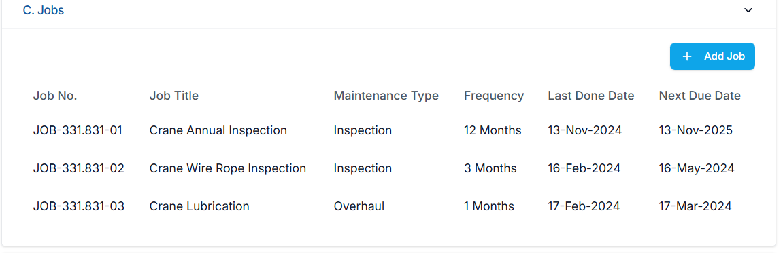

5.1 Layout of Section C
- Shown as a collapsible card:
C. Jobs
- Contains:
  - Add Job button (visible only to Office and PMS Admin)
  - Jobs Table displaying all jobs linked to the component
  - Pagination or scroll depending on job count (future expandable)
The table has the following columns exactly as per your screenshot:
Column | Meaning
Job No. | Unique job identifier generated from Component Code + job sequence
Job Title | Name/description of job
Maintenance Type | Inspection / Overhaul / Replacement / Servicing etc.
Frequency | Calendar or Running Hour frequency
Last Done Date | Last time maintenance was completed
Next Due Date | Automatically calculated (calendar jobs only)
Actions | per-row buttons for creating work orders on demand.
For running hour jobs, Next Due Date is not shown — instead PMS uses running-hour triggers and shows remaing hours instead.

5.2 Job Numbering Logic
Each job has a unique identifier:

5.2.1 Format Example (From Screenshot)
J0B-331.831-01
J0B-331.831-02
J0B-331.831-03

5.2.2 Components of Job Number
- Prefix: JOB or J0B (as used in screenshot)
- Component Code (SFI-based)
- Hyphen
- Sequence number (02, 03, 04, etc.)

5.2.3 Sequence Generation
When adding a new job:
- PMS finds highest sequence under this component
- Generates next number automatically
- No user input required
Example:
If last is J0B-331.831-03
→ next = J0B-331.831-04

5.3 Job Source & Data Creation
Jobs may enter PMS by:

5.3.1 Admin Excel Upload (Primary Source)
The most common method. Excel contains:
- Component Code
- Fleet Equipment Code
- Job Titles
- Maintenance Types
- Frequencies
- Last Done Information
- RH/Hr-based indicators
- Lead Time (in hours or days)
These are imported in Admin module.

5.3.2 Manual Job Creation (“Add Job” Button)
Allowed only for:
- Office users
- PMS Software Provider
When a job is manually added, ship users will NOT see it until the Office approves it (if your workflow requires that — we can define it in Modify PMS but you haven’t yet).

5.3.3 Modify PMS Request (for ship-initiated changes)
Ship cannot add or edit jobs here.
They must submit a request through Modify PMS.

5.4 Maintenance Type
Each job has a Maintenance Type as defined in Excel template or office entry.
Valid types include (examples based on your screenshot and maritime practice):
- Inspection
- Overhaul
- Servicing
- Testing
- Cleaning
- Lubrication
- Replacement

Important:
Ship users CANNOT change Maintenance Type here.
Office & PMS Admin may modify it through Admin or Modify PMS workflow.

5.5 Frequency Logic (Critical Section)
There are two frequency types only:

5.5.1 Calendar-Based Frequency
Examples:
- 1 Month
- 3 Months
- 6 Months
- 12 Months
- Weekly (7 days)
- Bi-weekly (14 days)
Calendar jobs show Next Due Date in the table.

5.5.2 Running-Hour–Based Frequency
Examples:
- 250 hours
- 500 hours
- 1000 hours
RH-based jobs do not show Next Due Date.
Instead PMS calculates:
Remaining Hours = (Last Done RH + Frequency) – Current RH
And work-order creation follows lead-time logic.

5.6 Last Done Date Logic

5.6.1 Source of Last Done Date
- Taken from Admin Excel upload
- Or if blank → defaults to Component Installation Date
- If component is newly installed → installation date = baseline
- If Work Order is completed → Last Done Date gets auto-updated

5.6.2 Editable?
- Ship cannot edit
- Office cannot directly edit
- PMS Admin may edit through Admin interface
- Any ship request must go through Modify PMS

5.7 Next Due Date Calculation (Calendar Jobs Only)
For calendar-based jobs:
Next Due Date = Last Done Date + Frequency (in months/days)
Automatically calculated by PMS.

Important Rules
- User cannot manually override
- Ship cannot edit
- Next Due recalculates whenever:
  - Work Order is completed
  - Last Done Date changes (due to new job import or replacement)

5.8 Running-Hour–Based Job Scheduling
For RH-based jobs:

Next Due Date is not displayed
(As per your strict instruction)
Instead PMS uses:
Trigger Point = Last Done RH + Frequency
And when:
Current RH >= Trigger Point – Lead Time
A Work Order is automatically generated.

Lead Time
- Stored in Admin module
- Can be set per job frequency category
- (Example: 200 hours before due date)
- PMS checks RH updates from:
  - Running Hours Module
  - Section B quick updates
  - Parent delta propagation

5.9 When Does a Work Order Get Created?
Work Orders are created automatically when job criteria are met.

1. Calendar Job
Today >= Next Due Date – Lead Time (days)

2. Running-Hour Job
Current RH >= (Last Done RH + Frequency) – Lead Time (hours)
When triggered:
- Work Order appears in Work Orders Module
- Assigned to the relevant user (Chief Engineer or assigned rank)
- Ship staff cannot modify job definition, only complete Work Order

5.10 Table Behaviour

Sorting
- Table should allow sorting by:
  - Job Number
  - Job Title
  - Maintenance Type
  - Last Done Date
  - Next Due Date

Collapsing
- Even when Section C is collapsed, PMS should show at least 1–2 job rows as a preview.

Scrolling
- If more jobs exist, table should scroll internally without collapsing other sections.

5.11 Add Job Button Behaviour
The “Add Job” button:
- Visible only for Office & PMS Admin
- Hidden for Ship staff

When clicked:
- Opens “Add Job” modal
- Fields include:
  - Job Title
  - Maintenance Type (dropdown)
  - Calendar or RH-based
  - Frequency
  - Last Done Date
  - Additional Notes

Job Code Auto-Generation:
- PMS auto-assigns next sequence number
- No manual code entry required

After saving:
- Job appears in Job Table
- If created from ship-side request → must pass through Modify PMS for office approval

5.12 Permissions
Action | Ship | Office | PMS Admin
View job list | Yes | Yes | Yes
Add job | No | Yes | Yes
Edit job | No (via Modify PMS only) | Yes | Yes
Delete job | No | Yes | Yes
Modify frequency | No | Yes | Yes
Modify maintenance type | No | Yes | Yes
Modify last done date | No | No (except via WO completion) | Yes
Trigger WO | No (auto) | Auto | Auto
Ship views only.
All edit capabilities are controlled by office/admin.

5.13 Data Sources
Jobs come from:
- Admin Excel Upload (main source)
- Manual job creation (office)
- Modify PMS (ship proposes, office approves)
- Fleet Equipment Code template (future scalable behaviour)
- Component Code mapping

5.14 Job Row Actions – Create Work Order Now
Each job row in Section C includes an Actions icon at the far right (small work-order/clipboard icon). This button allows the user to generate a Work Order on demand for that specific job, even if it is not yet due.
Purpose
- To allow early execution of a scheduled job (e.g., during port stay, drydock, or convenient opportunity).
- To allow execution of the same job in case of breakdown/defect, while still crediting the original job cycle.
Who can use it
- Ship users: Yes – can click the icon to create a WO.
- Office / PMS Admin: Yes – same behaviour.
Behaviour when clicked
- System opens the standard Planned Work Order Form (Part A + Part B) for that job.
- The form is pre-filled with:
  - Component
  - Job Title
  - Maintenance Type = “Scheduled Maintenance” (or the job’s maintenance type)
  - Job Number / Job ID
  - Frequency / RH data (read-only)
  - Default “Assigned To” and “Approver” (as per job settings or company rules).
- A hidden flag is stored on the Work Order, e.g. created_from_job = TRUE (and optionally creation_mode = 'ON_DEMAND').
- User can edit only the normal WO fields (assigned rank, dates, spares, tools, safety requirements, etc.) – they cannot change the underlying job frequency or template here.
Effect on Job Cycle after completion
When this on-demand Work Order is completed and approved:
- It is treated exactly like a normal scheduled WO for that job:
  - Last Done Date and/or Last Done Running Hours in Section C – Jobs are updated using the completion data from the WO.
  - Next Due Date (for calendar jobs) or Next Due RH threshold (for RH jobs) is recalculated from this new “Last Done” value.
- If there is already an auto-generated scheduled WO for the same job and cycle, the system will:
  - Mark that older WO as “Superseded by early completion” or auto-cancel it (as per final WO module rules), and
  - Ensure only the new completed WO is used for history and cycle reset.
This makes the “Create Work Order” button the standard way to:
- Perform jobs early, and
- Handle breakdown repair that is essentially the same as an existing job,
while keeping PMS cycles, history, and compliance fully correct.

SECTION 6 — D. MAINTENANCE HISTORY
(Work Order Completion Records — Immutable History)
Section D shows the historical maintenance record for the selected component.
This history is automatically generated from Work Orders — never manually edited.
This section ensures PMS maintains a real, auditable, tamper-proof record of all maintenance performed on a vessel.
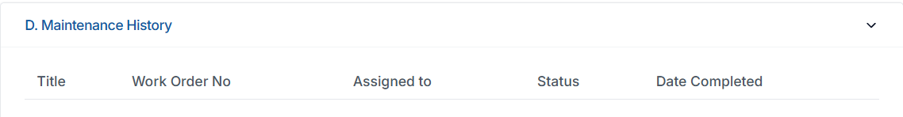

6.1 Section Layout
Displayed as a collapsible panel:
D. Maintenance History
The panel contains a table with the following columns (exactly as seen in your screenshot):
Column | Meaning
Title | Work Order title (taken from job title)
Work Order No | Unique WO identifier
Assigned To | Person/Rank who completed the job
Status | Status of the work order (Completed/Approved)
Date Completed | Final approval date
If no maintenance history exists, the table appears empty.

6.2 Purpose of Maintenance History
Section D provides:
- A complete audit of all maintenance ever performed on this equipment
- Statutory traceability for inspections, overhauls, and compliance
- Direct evidence for:
  - PSC inspections
  - Class surveys
  - Vetting inspections
  - Accident investigations
  - OEM warranty claims
This section is a read-only log for all users.

6.3 Source of Maintenance History
Maintenance History comes only from completed and approved Work Orders in the Work Orders Module.

Flow:
- Job is triggered (calendar or RH-based).
- Work Order is generated.
- Assigned engineer completes the Work Order.
- WO goes for approval (usually Chief Engineer → Office).
- When the WO is approved:
  - Last Done Date (in Jobs Section C) updates
  - Maintenance History (Section D) gets a new entry
  - Work Order becomes immutable

6.4 When is a History Record Created?
A new entry is inserted into Section D only after:
- Work Order is submitted, verified, and approved.
Until approval, nothing appears in Maintenance History.

6.5 Fields Explained in Detail

1. Title
- The job title copied from the corresponding job definition.
- Example: “Crane Wire Rope Inspection”

2. Work Order No
- Unique ID generated by PMS when WO is created.
- Format depends on WO module spec (not assumed here).

3. Assigned To
- The person/rank who executed/completed the WO.
- Example: “2/E”, “Fitter”, “Motorman”

4. Status
Possible values:
- Approved (final and locked)
- (Work Orders in any other state are NOT shown here)

5. Date Completed
- Date on which Work Order received final approval.
- NOT the date when user submitted the Work Order.

6.6 Data Integrity Rules (Critical)

Rule 1: Immutability
Once a maintenance history entry is created:
- It cannot be edited
- It cannot be deleted
- Not even by PMS Admin
This ensures PMS passes all audits.

Rule 2: No Manual Entries
Ship staff or office cannot add history manually in Section D.
All entries must originate from Work Orders.

Rule 3: RH-based logic sync
For RH-based jobs:
- When WO is approved:
  - Last Done RH updates (in Jobs Section C)
  - History entry is added
  - Remaining hours reset

Rule 4: Calendar-based next-due sync
When WO is approved:
- Next Due Date recalculates
- History entry logs correct date

Rule 5: Component Replacement
If component is replaced (via Modify PMS workflow):
- PMS should:
  - Close out existing WO cycles
  - Reset RH for the component
  - Create a special history entry:
“COMPONENT REPLACED”
(This behaviour can be finalized later if needed.)

6.7 Table Behaviour
- Table expands vertically as history grows.
- Oldest entries appear at bottom; newest at top (unless you want reverse — will follow your preference).
- Sorting should ideally be available by Date or WO Number.
- Pagination optional based on volume (we can define later).

6.8 Permissions Summary
Action | Ship | Office | PMS Admin
View history | Yes | Yes | Yes
Add history | No | No | No
Edit history | No | No | No
Delete history | No | No | No
Only Work Order approvals create history.

6.9 Dependencies
Maintenance History depends on:
- Jobs (Section C)
- Work Orders Module
- Running Hours Module
- Modify PMS (for replacement events)
Section D is completely independent of direct manual user input.

SECTION 7 — E. SPARES
(Vessel-Specific Spare Parts Linked to Each Component)
Section E shows all spare parts that are linked to the selected component for the selected vessel.
This section is important because spares are directly used for:
- Maintenance planning
- Inventory control
- Issue/consume operations
- Reorder logic
- Critical spares tracking
- Regulatory and SFI-aligned spare grouping
- IHM (Inventory of Hazardous Materials) compliance
This specification includes only real behaviour as per your instructions — no assumptions.
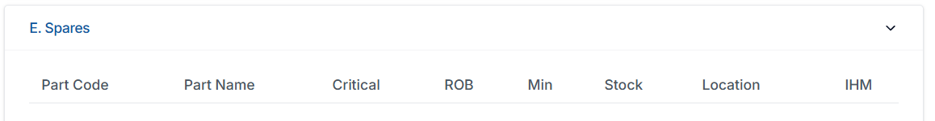

7.1 Section Layout
Displayed as a collapsible panel titled:
E. Spares
The content is in tabular form with the exact columns visible in your screenshot:
Column | Meaning
Part Code | Unique spare identifier
Part Name | Name/description of the part
Critical | Whether spare is critical (Yes/No)
ROB | Remaining On Board (current stock quantity)
Min | Minimum required stock
Stock | Actual recorded stock (if separate from ROB)
Location | Storage location onboard
IHM | IHM classification (Yes/No)
If no spares are linked to this component, the table appears empty.

7.2 Purpose of Spares Section
This section allows users to see all spare parts required for the equipment, including:
- Critical spare parts
- Stock availability
- Minimum stock requirements
- Locations onboard
- Whether the spare is IHM regulated
This supports:
- Work Order execution
- Inventory planning
- Critical spare compliance
- PSC/Class inspections
- Preparation for drydock
- Procurement planning (future integration)

7.3 Data Source for Spares
All spares are populated from the Admin Excel Upload (Spare Parts Master template) and from the Spares/Stores modules.
For each spare part:
- A link exists between Part Code and Component Code.
- Only spares linked to this specific vessel are shown here.

7.3.1 Levels of Spare Data (as you defined):
- Vessel Level → Shown here (Section E)
- Fleet Level → Not shown
- Company Level → Not shown
(Fleet/company templates may exist but are not displayed in this component-level view.)

7.4 Field-by-Field Behaviour

1. Part Code
- Unique identifier for the spare.
- Comes from Admin Excel sheet.
- Clicking Part Code (future enhancement) may open spare details — not implemented yet.
Editable by:
- PMS Admin only
- Ship cannot modify
- Office cannot modify here

2. Part Name
- Human-readable spare name.
- Vessel-specific description.
Editable by:
- PMS Admin
- Office (depending on admin template permissions)
- Ship cannot edit here

3. Critical (Yes/No)
Represents whether the spare is a critical spare, separate from component criticality.
Important point (from you):
- A non-critical component may have critical spare(s)
- A critical component may have non-critical spares
Editable by:
- Office
- PMS Admin
Ship cannot change the criticality.

4. ROB (Remaining On Board)
Represents the actual available quantity of the spare onboard.
ROB is updated via:
- Stores Module
- Issue/Consume actions
- GRNs (future procurement module integration)
Displayed here only for reference.
Ship cannot edit ROB in this section.

5. Min (Minimum Required Stock)
Represents the minimum quantity required for compliance or safe operation.
Editable by:
- Office
- PMS Admin
Ship cannot modify.
Used for reorder calculations in Stores/Purchases (future).

6. Stock
If PMS distinguishes between ROB and Stock (system-specific behaviour from your screenshot):
- ROB = physically available
- Stock = accounted inventory quantity
We follow your UI screenshot exactly:
- Display Stock as a separate column
- Keeps ROB and Stock fields independent
Editable only via inventory modules, not here.

7. Location
Storage location onboard (e.g., Engine Store Room, Deck Store, Workshop Cabinet).
Editable by:
- Office
- PMS Admin
Ship cannot edit here; any updates must go through Stores/Inventory module.

8. IHM (Yes/No)
Indicates whether the spare is listed under IHM (hazardous materials).
Editable by:
- Office
- PMS Admin
Not editable by ship in this panel.

7.5 Add/Edit Spare (Not in this Screen)
Important rule (per your instruction):
👉 Ship user CANNOT add or modify spare linking here.
👉 Office user CANNOT add or modify spare linking here.
👉 PMS Admin may update linking only in Admin module.
The “Add Job” equivalent does NOT exist in Section E.
All spare linking must happen in the Admin Upload templates or later via dedicated Spares UI.

7.6 Table Behaviour

Sorting
Table should support sorting by:
- Part Code
- Part Name
- Critical
- ROB
- Min
- Stock
- Location

Scrolling
If spares exceed panel height, table scrolls internally.

Collapsed View Preview
When Section E is collapsed:
- Show 1 preview row (Part Code + Part Name)
- Helps users identify that spares exist without expanding fully

7.7 Permissions Summary
Action | Ship | Office | PMS Admin
View spares | Yes | Yes | Yes
Add spare | No | No | Yes (Admin Module)
Edit spare | No | No | Yes
Modify ROB | No | No | Through Inventory Module
Change linking | No | No | Yes
View IHM | Yes | Yes | Yes
Modify IHM | No | Yes | Yes

7.8 Interactions With Other Modules

1. Work Orders
- Spare list is shown during WO execution
- Ship can select spare consumption in WO → affects ROB elsewhere
- Section E remains read-only

2. Stores / Spares Module
- All ROB and Stock values originate from this module
- Section E only shows data

3. Inventory Audit Trail
- Adjustments happen in Inventory module
- Reflected passively here

4. Modify PMS
- Ship may propose spare changes but cannot edit here
- Office reviews in Modify PMS

7.9 Data Integrity Rules
- No manual editing of spares here
- No addition/deletion from Section E
- All changes controlled by Admin or Inventory submodules
- Only spares belonging to selected vessel appear
- No merging from fleet/company templates

SECTION 8 — F. DRAWINGS & MANUALS
(Centralized Document Storage — Component-Specific Technical Files)
Section F provides all technical documents associated with the selected component.
These include equipment manuals, drawings, catalogues, OEM documents, datasheets, installation diagrams, maintenance booklets, and other vessel-specific files.
These documents help ship staff and office teams reference the correct technical material when:
- Performing maintenance
- Preparing for drydock
- Completing Work Orders
- Assisting class/PSC inspections
- Ordering spares
- Verifying technical parameters
The section’s behaviour must follow your instructions exactly:
- Ship can VIEW
- Office can VIEW & DOWNLOAD
- Ship CANNOT download
- Files are stored centrally
- Linked via Component Code & Fleet Equipment Code
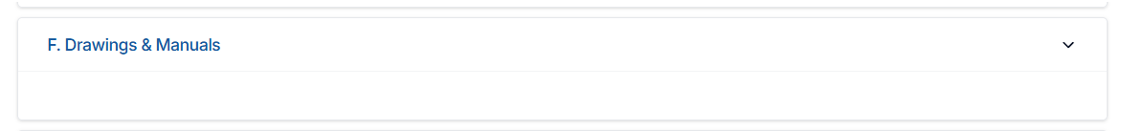

8.1 Section Layout
Displayed as a collapsible card:
F. Drawings & Manuals
Inside the panel:
A file list table with columns (format adjusted to match your UI):
Column | Meaning
File Name | The name of the manual/drawing
Type | Manual / Drawing / OEM Doc / Catalogue / etc.
Version | Optional (if versioning is enabled later)
Uploaded By | User who uploaded
Uploaded On | Date of upload
Actions | “View” icon (for all), “Download” icon (office/admin only)
Initially, the table may be empty for components without documentation.

8.2 Purpose of Drawings & Manuals Section
This section serves three key purposes:
- Access to all equipment documentation from anywhere in the system.
- Ensures the same manuals/drawings appear in:
  - Work Order module (during job execution)
  - Reports (if needed)
- Reduces dependency on ship’s scattered PDF files by centralizing documents in PMS Document Library.

8.3 Data Sources
Files are not uploaded through Section F itself.
They originate from:

1. Admin Excel Upload Package (initial PMS onboarding)
Some manuals/drawings may be included in onboarding packages.

2. PMS Admin Document Upload Interface
Software Provider can upload all manuals centrally:
- Organised by Component Code
- Fleet Equipment Code
- Maker / Model categories

3. Office Upload Interface
Office may upload:
- Custom drawings
- Vessel-specific modifications
- Updated manuals
- OEM files

4. Modify PMS
Ship can request:
- “Add New Manual”
- “Add Updated Drawing”
Office approves → file then appears in Section F.

8.4 View-only Behaviour (Ship)
Ship user permissions:
- Ship staff CAN view file directly in embedded PDF viewer.
- Ship staff CANNOT download the file.
- No right-click/save permitted (ideal behaviour, depends on browser restrictions).
- No upload/delete allowed.
This is essential because ships often operate under:
- OEM copyright restrictions
- Document confidentiality controls
- Vetting / Oil Major compliance requirements
Viewer behavior:
- When user clicks “View” icon → opens PDF viewer modal
- PDF viewer supports:
  - Zoom
  - Scroll
  - Page navigation
  - Fullscreen toggle
No additional tools.

8.5 Office/Admin Behaviour
Office and PMS Admin have more control.

Allowed:
- View
- Download
- Replace file
- Add new file
- Delete file

Download restriction:
- Allowed only for Office and PMS Admin
- Download button must not appear for ship staff

File Replacement Process:
Replacing a file must preserve:
- Upload history
- Versioning (if implemented)
Simple behaviour (current):
- Office/Admin deletes old file
- Uploads new file
- System records new timestamp

8.6 File Types Allowed
By design, the section must support:
- PDF (primary format for manuals)
- JPEG, PNG (if diagrams are images)
- DOCX (Office may upload, system should convert to PDF if possible in future)
- XLSX (only if needed for component-specific data; viewer may not load these)
But for ship users:
- Viewer is always PDF viewer
- Non-PDF files must open via download (office only)
- Ship CANNOT open non-PDF file unless converted
This maintains safety and consistency.

8.7 File Linking Rules
Each file is linked to a component via:

Primary Keys
- Component Code
- Vessel Code

Optional Cross-Link
- Fleet Equipment Code (FEC)
Linking via FEC allows:
- Automatic preloading of manuals across vessels with identical equipment
- Vessel-specific documents override fleet documents if needed

8.8 UI Behaviour

When Section F is Expanded:
- Full file list shown.

When Section F is Collapsed:
- Show small preview chip:
e.g., “3 manuals attached”
- This ensures user knows documentation exists.

Table Behaviour
- Sortable by File Name and Date
- Icons must be intuitive:
  - Eye icon = View
  - Download icon = Admin/Office only
If you want consistent icons, I can specify exact icon library later.

8.9 Upload & Delete Actions (Permissions)
Action | Ship | Office | PMS Admin
View file | ✔️ | ✔️ | ✔️
View PDF in viewer | ✔️ | ✔️ | ✔️
Download file | ❌ | ✔️ | ✔️
Upload file | ❌ | ✔️ | ✔️
Delete file | ❌ | ✔️ | ✔️
Replace file | ❌ | ✔️ | ✔️

8.10 Data Integrity Rules
- Files must be stored centrally, not vessel-side.
- Deleting a file must log:
  - Who deleted
  - Timestamp
  - File Name
  - Component Code
- Ship cannot lose access to essential documentation due to deletion errors — hence:
  - PMS Admin should confirm deletions
  - Versioning may be enabled in future
- Files must remain searchable by:
  - File Name
  - Component Code
  - Fleet Equipment Code
  - Maker
  - Model

8.11 Interaction With Other Modules

1. Work Orders
During job execution, ship staff can:
- Open manuals directly from Section F
- Viewer must open in WO module as well

2. Modify PMS
Ship can request:
- "Upload New Manual"
- "Add Document"
Office approves → file appears in Section F.

3. Reports
Future:
- “Documentation Compliance Report” may use Section F data.

SECTION 9 — G. CLASSIFICATION & REGULATORY DATA
(Component-Level Class Surveys, Certificates & Regulatory Compliance)
Section G displays all class-related and regulatory compliance requirements associated with the selected component.
These may include:
- Class survey requirements (Annual, Intermediate, Renewal, Special, Damage)
- OEM certification
- Statutory compliance items
- Company-specific requirements
- Equipment test requirements
It is critical because inspectors and auditors rely heavily on this section.
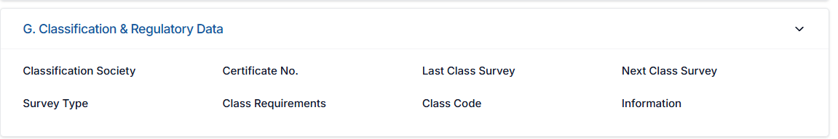

9.1 Section Layout
Shown as a collapsible panel:
G. Classification & Regulatory Data
Inside the panel is a table with columns (exactly as seen in screenshot):
Column | Meaning
Classification Society | Example: DNV, ABS, LR, IRS
Certificate No. | Certificate reference number
Last Class Survey | Date last class survey was completed
Next Class Survey | Date next survey is due
Survey Type | Type of survey (Annual, 5-year, Intermediate, etc.)
Class Requirements | Text or reference of requirement
Class Code | Internal class code (optional)
Information | Notes / remarks
Empty state shows blank table.

9.2 Purpose of This Section
To record:
- All class-required actions for this equipment
- All certificate details
- Past survey and next survey due dates
- Inspection/test requirements
- Company regulatory requirements
- Any additional compliance notes
This section supports Ship, Office, Class Surveyors, and Auditors.

9.3 Multi-Row Survey Support (CRITICAL)
You confirmed:
👉 Each component may have multiple surveys.
This is essential for:
- Cranes → Annual + 5-year + Load Test
- Main Engines → Multiple cylinder inspections, annual performance tests
- Boilers → Internal & external inspections
- Safety equipment → Multiple statutory cycles
Therefore, PMS must support multiple rows per component.
Each row is a separate class/regulatory requirement.

9.4 Data Source
Class data may come from:

9.4.1 Admin Excel Upload
During initial PMS onboarding:
- Class survey details
- Certificate numbers
- Survey types
- Historical dates

9.4.2 Manual Entry by Office
Office staff (Superintendent / Marine / Technical) may add or update:
- Survey dates
- Requirements
- Information field

9.4.3 Modify PMS (Future)
Ship may propose:
- Updates to Class data
- Fixes to incorrect survey dates
Office must approve before it updates Section G.

9.4.4 Certificate Upload (linked to Section F)
Related certificates can be uploaded in Drawings & Manuals.

9.5 Field-by-Field Logic
Below is the precise description of each column.

1. Classification Society
Examples:
- DNV
- ABS
- Lloyd’s Register
- ClassNK
- RINA
- IRS
Editable only by:
- Office
- PMS Admin
Ship cannot modify.

2. Certificate No.
- Exact certificate reference number for that survey/inspection.
- May be uploaded from initial Excel or entered manually.
Editable by:
- Office
- PMS Admin
Ship cannot edit.

3. Last Class Survey
Date of last survey performed.
Logic:
- Editable by Office
- Set automatically when survey Work Order (future) is approved
- Ship cannot edit
If empty, it may mean:
- New equipment
- No previous survey data
- Data not yet entered by office

4. Next Class Survey
Expected due date of next survey.
Logic:
- Office enters this manually
- May be calculated by applying survey rules (if you add this functionality later)
- Ship cannot modify
This field is required for:
- Survey tracking
- Vetting
- PSC/Class inspections

5. Survey Type
Examples:
- Annual Survey
- 5-Year Survey
- Intermediate Survey
- Damage Survey
- OEM Test
- Statutory Requirement
- Internal Company Requirement
Editable by:
- Office
- PMS Admin
Ship cannot change.

6. Class Requirements
Text describing requirement for this component.
Examples:
- “Annual load test required as per DNV rules.”
- “5-year overhaul mandatory.”
- “Hydrostatic test required.”
- “Wire rope renewal every 5 years.”
Editable by:
- Office
- PMS Admin

7. Class Code
Optional internal code issued by classification society.
Used for:
- Identification
- Mapping to regulatory documents
Editable only by Office and Admin.

8. Information
Free text notes.
Examples:
- “Survey postponed due to port restrictions.”
- “OEM inspector attended.”
- “Next survey aligned with drydock schedule.”
Editable by:
- Office
- PMS Admin
Ship cannot edit.

9.6 Add/Edit Survey Row
Buttons/Actions:

Office:
- Can add new row
- Can edit existing rows
- Can delete row (with audit trail)

Ship:
- Cannot add/edit/delete
- Can only see the list
If ship wants to modify survey data:
👉 Must raise change request through Modify PMS.

9.7 Table Behaviour

Sorting
Supported on:
- Survey Type
- Last Survey
- Next Survey
- Classification Society

Collapsing
If Section G is collapsed:
- Show a preview (“2 Class Surveys”, “3 Regulatory Items”)
- Helps users understand there is data inside

9.8 Data Integrity Rules
- No manual changes by ship.
- Office must maintain accurate survey data.
- Each update must be logged with:
  - User
  - Timestamp
  - Before/after values
- Filing errors can only be corrected by office/admin.
- If certificates are attached in Section F, cross-reference can be shown in Section G (optional future enhancement).

9.9 Interaction With Other Modules

1. Drawings & Manuals (Section F)
Class certificates uploaded there.

2. Work Orders (Future Enhancement)
If you later implement “Survey WO”:
- WO approval updates “Last Class Survey” automatically
- And recalculates “Next Class Survey”

3. Modify PMS
Ship requests changes, office approves.

SECTION 10 — H. REQUISITIONS
(Placeholder for Future Purchase/Stores Integration — Collapsed by Default)
Section H represents the future area where all purchase requisitions linked to the selected component will appear.
This includes:
- Spare part requisitions
- Service requisitions
- Repair requisitions
- Consumable requests
However, as per your direct instruction, the functionality must not be implemented now, and the panel must remain collapsed.
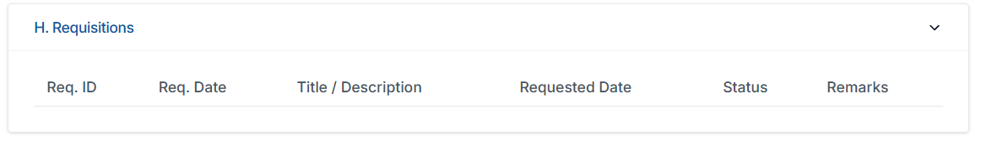

10.1 Section Layout
Displayed as a collapsible panel:
H. Requisitions

Current Behaviour (Mandatory):
- The panel remains collapsed by default.
- The contents inside the panel should NOT be implemented.
- Only the panel header is visible.
This respects your requirement:
“just collapse the pane.”

10.2 Table Design (For Future Use — Do Not Implement Functionality)
The table shown in your screenshot contains columns:
Column | Purpose
Req. ID | Unique requisition identifier
Req. Date | Date requisition was created
Title / Description | Summary of requested item or service
Requested Date | Date the item/service is needed
Status | Draft / Submitted / Approved / Ordered (future)
Remarks | Free text comment

Important:
- These columns must exist only visually, for layout reference if developer needs to style UI.
- But all logic behind them is disabled.

10.3 Behavioural Rules (As per your instruction)

1. User Interaction
- Ship: Cannot click anything, cannot add requisitions.
- Office: Cannot add/edit requisitions yet.
- PMS Admin: Should not add/edit anything from this panel.

2. No Data Loading
- Table should remain empty.
- No backend calls or data retrieval.

3. No Buttons
- No “Add Requisition” or “Edit” button should exist.

4. Fully Collapsed
- When the user expands the panel manually:
  - Show the empty table for layout reference only.
  - But keep all rows non-interactive.
  - No selection allowed.

5. No Links to other Modules
- No linking to Stores, Purchases, or Inventory yet.
- No pop-ups, no forms, no redirects.

10.4 Future Scope (Document Only — No Implementation Now)
If developed later, Section H will eventually support:
- Creating component-linked requisitions
- Auto-filling part codes
- Workflow for approval
- Linking to purchase orders
- Linking to inventory receipts
- Vendor selection
- Integration with IMPA codes (if added)
However, none of these should be implemented now.

10.5 Permissions Summary
Action | Ship | Office | PMS Admin
View collapsed panel | Yes | Yes | Yes
Expand panel | Yes | Yes | Yes
Add requisition | ❌ | ❌ | ❌
Edit requisition | ❌ | ❌ | ❌
Delete requisition | ❌ | ❌ | ❌
Trigger workflow | ❌ | ❌ | ❌

10.6 Mandatory Instruction to Developers
“Do not build any functional API, UI flow, or database calls for Section H.
Keep it as a collapsed placeholder EXACTLY as per screenshot.”
This must be respected to avoid misaligned development.

SECTION 11 — ROLE-BASED ACCESS (COMPONENTS MODULE)
There are three major user groups in the PMS related to this module:
- Ship Users
(Master, Chief Engineer, 2/E, Electrical Officer, etc.)
- Company Office Users
(Technical Superintendent, Marine Superintendent, Crewing/HSSEQ if required)
- PMS Software Provider (Admin)
(Developers / Implementers with full control)
Each role has different levels of visibility and modification rights.
The Components Module is sensitive, as incorrect editing can corrupt the PMS.
Below is the exact access matrix based ONLY on the rules you provided.

11.1 SHIP USERS (ONBOARD CREW)

Overall Access Level:
View-only for Components Module
Can update Running Hours (via RH module or quick edit)
Cannot modify structure or master data

11.1.1 Allowed Actions
- View entire component tree
- Expand/collapse SFI levels
- Select components and view Sections A–H
- Update Running Hours (Section B quick edit + RH module)
- View Jobs list (Section C)
- View Maintenance History (Section D)
- View Spares (Section E)
- View Manuals (Section F — PDF viewer only)
- View all Class/Regulatory rows (Section G)
- Expand Requisitions (Section H collapsed placeholder)

Additional allowed:
- Propose changes through Modify PMS module
(e.g., adding new component, changing job frequency)

11.1.2 Restricted Actions (NOT allowed)
Ship users CANNOT:
- Add/edit/delete components
- Change Component Name
- Change Component Code
- Change Parent Code
- Add/edit/delete jobs
- Change job frequency or type
- Modify spares
- Add/edit manuals
- Download manuals
- Change class data
- Add/edit/delete class survey rows
- Create or edit requisitions in Section H
- Modify criticality status
- Modify IS Parent or IS Active flags
- Upload any files
- Change any technical details in Section A

11.1.3 Ship User Summary
Ship can view everything, update Running Hours, and propose changes,
but cannot change PMS structure or critical data.

11.2 COMPANY OFFICE USERS

Overall Access Level:
Full edit access for vessel-specific data, not fleet-wide structures.
Office users include:
- Technical Superintendent
- Marine Superintendent
- HSSEQ (for certain components)
- Company Admins

11.2.1 Allowed Actions

Component Information (Section A)
Office can edit:
- Component Name
- Maker
- Model
- Serial Number
- Drawing Number
- Location
- Critical (Yes/No)
- Condition Based (Yes/No)
- Commissioning Date
- Rating
- Department
- Installation Date
- IS Active (Yes/No)
- Notes
Office cannot edit:
- Fleet Equipment Code
- Maker Code
- Model Code
- Component Code
- Parent Component Code
- IS Parent flag

Running Hours (Section B)
- Office can update Running Hours (quick edit)
- Office can view delta propagation (system-controlled)
- Office cannot edit RH logic

Jobs (Section C)
Office can:
- Add new jobs
- Edit job title
- Modify Maintenance Type
- Change Frequency
- Change Last Done Date (only via Admin/approval)
- Delete job (with caution — triggers Modify PMS review)
Office cannot:
- Modify Fleet-wide job templates
- Modify job numbering logic
- Edit PMS structure

Maintenance History (Section D)
Office can:
- View complete history
- Approve Work Orders (done in WO module)
Office cannot:
- Edit history
- Delete history

Spares (Section E)
Office can:
- Edit spare criticality
- Edit spare minimum quantity
- Edit spare location (depending on Stores module behavior)
Office cannot:
- Create new spare part codes
- Modify vessel-fleet-company hierarchy
- Delete spares from PMS here

Manuals (Section F)
Office can:
- Upload manuals
- Replace manuals
- Delete manuals
- Download manuals
Ship cannot download.

Class/Regulatory (Section G)
Office can:
- Add survey rows
- Edit class details
- Delete survey rows

Requisitions (Section H)
Office cannot:
- Add requisitions (future)
Panel remains collapsed.

11.2.2 Restricted Actions
Office cannot:
- Change any Fleet-wide master data
- Change SFI structure
- Assign or modify Fleet Equipment Code
- Modify Maker Code / Model Code
- Edit Component Code
- Delete major components without Modify PMS approval
- Modify IS Parent flag
- Change component hierarchy
- Bypass PMS Admin restrictions

11.2.3 Office User Summary
Office can edit vessel-specific data, manage jobs, class, spares, manuals,
but cannot modify fleet templates or core PMS architecture.

11.3 PMS SOFTWARE PROVIDER (ADMIN)

Overall Access Level:
Full unrestricted access (Fleet + Vessel + Global Master Data).
This user controls:
- PMS templates
- SFI structure
- Fleet Equipment Codes
- Admin Excel Uploads
- All customization
- New fields, label editing, structure changes

11.3.1 Allowed Actions
PMS Admin can:

Component Structure
- Add/edit/delete any component
- Modify Component Code
- Modify Parent Code
- Change SFI hierarchy
- Change IS Parent flag
- Change any label in the UI
- Add/remove fields
- Modify categories, departments
- Upload initial PMS via Excel templates

Jobs
- Add/edit/delete jobs
- Modify job numbering logic
- Modify job frequency & type
- Change fleet-wide job templates

Spares
- Add/edit/delete spares at fleet/company/vessel level
- Modify spare linking
- Set IHM linkage

Manuals/Documents
- Upload, replace, delete
- Manage centralized document library

Class/Regulatory
- Fully editable
- Import via Excel
- Configure class survey templates

Running Hours
- Edit RH values
- Edit parent/child RH logic
If needed, Admin can override any values.

11.3.2 Restricted Actions (None)
PMS Admin has no restrictions except:
- Must maintain system integrity
- Cannot bypass audit logs

11.3.3 PMS Admin Summary
PMS Admin can modify everything, including SFI structure, template fields, and master data.
This is the top-level configuration authority.

11.4 Role Matrix Summary Table
Action | Ship | Office | PMS Admin
View Component Tree | ✔️ | ✔️ | ✔️
Add Component | ❌ | Limited (vessel only) | ✔️
Edit Component | ❌ | Yes (limited) | ✔️
Delete Component | ❌ | Limited via Modify PMS | ✔️
Update Running Hours | ✔️ | ✔️ | ✔️
Edit Running Hours Logic | ❌ | ❌ | ✔️
View Jobs | ✔️ | ✔️ | ✔️
Add/Edit Jobs | ❌ | ✔️ | ✔️
Delete Jobs | ❌ | ✔️ | ✔️
View Maintenance History | ✔️ | ✔️ | ✔️
Edit History | ❌ | ❌ | ❌
View Spares | ✔️ | ✔️ | ✔️
Modify Spares | ❌ | Yes (vessel spares) | ✔️
View Manuals | ✔️ | ✔️ | ✔️
Download Manuals | ❌ | ✔️ | ✔️
Upload Manuals | ❌ | ✔️ | ✔️
View Class Data | ✔️ | ✔️ | ✔️
Edit Class Data | ❌ | ✔️ | ✔️
Requisitions (Placeholder) | View collapsed | View collapsed | View collapsed

SECTION 12 — DATA FLOW & BACKEND LOGIC (COMPONENTS MODULE)
(How Component Data Interacts With Running Hours, Jobs, WO, Spares, Class, Modify PMS, and Admin Uploads)
This section describes the end-to-end working logic behind the Components Module.
It defines:
- How component data is created
- How it moves through the PMS
- How it affects WO creation
- How RH propagation works
- How spare linking works
- How class data behaves
- How Modify PMS controls structural changes
This section ensures that the UI specification connects correctly with backend behaviour.

12.1 MASTER DATA SOURCES
Component data in PMS can originate only from three controlled entry points:

12.1.1 Admin Excel Upload (Primary Source)
This is the main onboarding mechanism. Admin uploads the full PMS in Excel templates:
- Component Register
- Jobs Master
- Spare Parts Master
- Maker/Model Data
- Class/Regulatory Data
- Document Index (optional)
This establishes the initial baseline.

12.1.2 PMS Admin Interface
The software provider can:
- Add components
- Edit core fields
- Change SFI structure
- Assign Fleet Equipment Codes
- Upload manuals
- Add/modify job templates
This is the only role that may change global PMS architecture.

12.1.3 Modify PMS (Ship → Office Approval Flow)
Ship proposes changes such as:
- New component
- Change of name
- Change in job frequency
- Add/remove spares
- Add new manual
Office approves → PMS updates live structure.
No change enters PMS without approval.

12.2 COMPONENT CREATION WORKFLOW

12.2.1 Admin/Office Creation
Admin creates a component by:
- Selecting a position in the SFI tree
- System determines next available code
- Admin completes Section A fields
- Component becomes active immediately

12.2.2 Ship-Initiated Creation
Ship follows:
- Ship clicks “Add Component”
- Fills all fields
- Submission goes to Modify PMS
- Office reviews & approves
- After approval → component appears in tree
- Jobs/spares linking happens after approval
Ship NEVER directly creates components in live PMS.

12.3 RUNNING HOURS BACKEND LOGIC (Critical Logic)
Running Hours are governed by the Delta Propagation Algorithm:

12.3.1 Parent RH Update
When parent component RH changes:

Step 1: System reads previous RH

Step 2: System reads new RH

Step 3: System calculates delta
Delta = New RH – Old RH

Step 4: For each child component
Child RH = Child RH + Delta

Step 5: System logs:
- Delta value
- New RH
- Timestamp
- User ID

12.3.2 Special Rule — Replacement Event
If child has RH reset to 0 due to replacement:
When parent delta occurs:
Child RH = 0 + Delta
Replacement events must be logged in Modify PMS and Section A “Notes”.

12.3.3 Work Order Trigger Check
After any RH update:
System checks every RH-based job under that component:
If Current RH >= (Last Done RH + Frequency – Lead Time)
→ Create Work Order automatically
Work Order is pushed to WO module.

12.4 JOB FREQUENCY & WORK ORDER LOGIC

12.4.1 Calendar-Based Job Trigger
Next Due = Last Done Date + Frequency (e.g. 6 months)
System checks:
Today >= Next Due – Lead Time (days)
→ Create WO
Ship cannot modify schedules.

12.4.2 RH-Based Job Trigger
Trigger = Last Done RH + Frequency
System checks:
Current RH >= Trigger – Lead Time (hours)
→ Create WO
No Next Due Date is shown for RH jobs.

12.4.3 When WO is Completed
- Ship completes WO form
- Office approves
- System updates:
  - Last Done Date
  - Last Done RH
  - Maintenance History (immutable)
  - Resets RH logic for next cycle
12.4.x On-Demand Work Orders from Jobs Section
In addition to auto-generated Work Orders (based on due date / running hours), the system supports on-demand WO creation directly from Section C – Jobs via the per-row “Create Work Order” icon.
Data flow:
- User clicks Create Work Order on a job row.
- System creates a new Work Order record with:
  - Link to component_code
  - Link to job_id / job_number
  - Flag created_from_job = TRUE and creation_mode = 'ON_DEMAND'.
- WO is edited and submitted/approved via the normal WO workflow.
- On approval:
  - component_jobs.last_done_date and/or last_done_rh are updated from the WO.
  - Job’s next due logic is recalculated.
  - Any existing auto-generated WO for that same job and cycle is closed/superseded so that there is only one valid completion per cycle.
- A history entry is inserted into component_maintenance_history as usual, with a reference to the on-demand WO.
This ensures that all early/breakdown executions still go through the Job → WO → History pipeline, and the job cycle remains consistent regardless of whether the WO was auto-generated or created on demand.

12.5 MAINTENANCE HISTORY PIPELINE
Maintenance History (Section D) is never manually modified.
It is filled ONLY by Work Orders.

Pipeline:
- Job triggers WO
- Ship executes WO
- Office approves WO
- PMS inserts new row into Maintenance History
History contains:
- Job Title
- WO No
- Assigned Person
- Status = Approved
- Date Completed
Absolutely immutable.

12.6 SPARES LINKING LOGIC

12.6.1 Spare-Part Linking Structure
Each spare is linked to a component via:
- Component Code
- Part Code
- Vessel Code

Spares DO NOT appear fleet-wide even if FEC is same.
Only vessel-specific spares appear in Section E.

12.6.2 Stock Logic
Stock values come from:
- Stores Module
- Issue/Consume
- Inventory Audit
- GRN (future)
Not editable in Components Module.

12.6.3 Critical Spare Logic
Each spare has its own Critical (Yes/No) independent of component criticality.
But both affect reports.

12.7 DOCUMENT & MANUALS LOGIC

12.7.1 Storage Mechanism
Files stored in central PMS Document Library indexed by:
- Component Code
- Fleet Equipment Code
- Vessel Code
- File Type
Ship can VIEW only.
Office/Admin can upload/delete/download.

12.7.2 Viewer Behaviour
- PDF viewer loads within modal
- Ship cannot download
- Office/Admin can download

12.8 CLASS & REGULATORY LOGIC

12.8.1 Multi-Survey Rows
Each component may have:
- Annual Survey
- 5-year Survey
- Intermediate
- Damage
- OEM tests
These rows are independent.

12.8.2 Update Logic
Only Office/Admin can:
- Add
- Edit
- Delete
Ship can view only.

12.8.3 Certificate Relationship
Certificates uploaded in Section F may correspond to survey rows in Section G.

12.9 MODIFY PMS WORKFLOW (CRITICAL CONTROL MODULE)
Modify PMS acts as the safety gate for all structural changes.

Ship can propose:
- New component
- Edit component name
- Change job frequency
- Add spare
- Add manual
- Change location
- Correction to wrong data

Office MUST approve before any update becomes active.
If rejected → no change to live data.
Modify PMS ensures:
- Data integrity
- Auditability
- Controlled configuration

12.10 ADMIN MODULE RELATIONSHIP
Admin module controls:
- Initial upload of PMS structure
- Component Register
- Job Master
- Spare Master
- Class Data
- Maker/Model master
- Lead Time for frequency triggers
- Document type master
- Component category master
Admin is the heart of system configuration.

12.11 BACKEND DATA MODEL SUMMARY
Core keys:
- Component Code
- Fleet Equipment Code
- Vessel Code
- Part Code
- Job Code
- Work Order No
All relational behaviour is driven by these fields.

12.12 AUDIT LOGGING (MANDATORY)
Every backend update must log:
- User ID
- Action
- Old Value → New Value
- Timestamp
- IP (optional)
- Vessel Code
- Component Code
Audit log MUST exist for:
- RH changes
- Job modifications
- Spare changes
- Document uploads
- Class survey updates
- Component creation/deletion
- Modify PMS approvals

SECTION 13 — DATABASE STRUCTURE / FIELD MAPPING (COMPONENTS MODULE)
This section defines the conceptual database structure for the Components module.
It is not a strict physical schema (column types, indexes, etc.), but a clear mapping of what tables are needed, what fields they must hold, and how they relate.
It covers only what we have explicitly defined so far for the Components module and its interactions (A–H sections + RH + Jobs + History + Spares + Manuals + Class).

13.1 Overview of Core Entities
For the Components module, PMS must maintain at least the following core tables/entities:
- components – Component master (Section A)
- fleet_equipment_master – Fleet Equipment definitions
- component_running_hours_log – RH updates + deltas
- component_jobs – Job definitions (Section C)
- component_maintenance_history – History (Section D)
- spares_master – Spare part master (global)
- component_spares_link – Mapping of spares to components (Section E)
- component_documents – Drawings & Manuals (Section F)
- component_class_regulatory – Class and regulatory rows (Section G)
- audit_log – Global audit logging (for all changes)
Work Orders, Inventory, Modify PMS, Admin, etc., will use their own tables but link to these.

13.2 components (Component Master – Section A)
Represents each equipment item onboard a specific vessel.
Table: components
Key fields:
- id – Internal primary key
- vessel_code – Vessel identifier
- component_code – SFI-based component code (per vessel)
- parent_component_code – SFI code of parent node (can also be parent_component_id if relational).
- fleet_equipment_code – Fleet-wide identifier (FEC)
- component_name
- component_category
- maker
- maker_code
- model
- model_code
- serial_number
- drawing_number
- location
- is_critical (Yes/No)
- is_condition_based (Yes/No – future use)
- commissioning_date
- rating
- department (Deck / Engine / Electrical)
- installation_date
- running_hours_current (for latest RH snapshot)
- is_active (Yes/No)
- is_parent (Yes/No)
- notes (text)
- created_by, created_at
- updated_by, updated_at
Relationships:
- 1 → many with component_jobs
- 1 → many with component_maintenance_history
- 1 → many with component_spares_link
- 1 → many with component_documents
- 1 → many with component_class_regulatory
- 1 → many with component_running_hours_log

13.3 fleet_equipment_master (Fleet Equipment Code Logic)
Defines fleet-level equipment types shared across vessels.
Table: fleet_equipment_master
Key fields:
- fleet_equipment_code (FEC – primary key)
- fleet_equipment_name
- maker
- maker_code
- model
- model_code
- description (optional)
- is_active
Relationships:
- 1 → many with components (same FEC used across vessels)
- May relate to job templates, spare templates, etc. (future).

13.4 component_running_hours_log (RH Log & Delta Tracking)
Stores every RH change for traceability.
Table: component_running_hours_log
Key fields:
- id
- vessel_code
- component_code
- previous_rh
- new_rh
- delta_rh
- updated_by (user id)
- updated_at (timestamp)
- update_source (e.g., RH_MODULE, COMPONENT_QUICK_EDIT)
This table is used for:
- RH propagation logic (parent → child)
- Audit trail
- RH-based job recalculation
components.running_hours_current should always reflect the latest RH; the log holds all history.

13.5 component_jobs (Jobs – Section C)
Represents all jobs linked to a component on a specific vessel.
Table: component_jobs
Key fields:
- id
- vessel_code
- component_code
- job_number (e.g., J0B-331.831-01)
- job_title
- maintenance_type (Inspection / Overhaul / etc.)
- frequency_type (CALENDAR or RUNNING_HOURS)
- frequency_value (numeric, e.g., 6, 250, 1000)
- frequency_unit (months/days/hours – as needed)
- last_done_date (for calendar jobs)
- last_done_rh (for RH jobs)
- lead_time_value (as configured in Admin)
- lead_time_unit (days/hours)
- is_active (Yes/No)
- created_by, created_at
- updated_by, updated_at
Relationships:
- Many component_jobs → 1 components
- Work Orders table will have job_id / job_number linking back here.

13.6 component_maintenance_history (Section D)
Stores immutable history entries for completed Work Orders.
Table: component_maintenance_history
Key fields:
- id
- vessel_code
- component_code
- job_id (FK to component_jobs)
- work_order_id (FK to WO table)
- title (job title snapshot)
- assigned_to (rank or name at the time)
- status (e.g., APPROVED)
- completed_at (final approval date)
- created_at (same as completed_at or log time)
Important rule:
No UPDATE or DELETE allowed on this table once row is created (at code level).

13.7 spares_master (Global Spare Definition)
Global spare definition for company/fleet/vessel.
(This table exists at system-level, but Components module reads from it.)
Table: spares_master
Key fields:
- part_code (unique)
- part_name
- description
- ihm_flag (Yes/No)
- maker (optional)
- unit_of_measure
- is_active
spares_master is used by multiple modules; Components only consumes it via link table.

13.8 component_spares_link (Section E)
Links spare parts to components for a specific vessel.
Table: component_spares_link
Key fields:
- id
- vessel_code
- component_code
- part_code (FK to spares_master)
- is_critical_spare (Yes/No)
- min_stock
- location (text or storage location code)
- created_at, created_by
- updated_at, updated_by
Stock/ROB normally live in Inventory/Stores tables, but Components uses ROB/Stock view joined via part_code + vessel_code.

13.9 Inventory / Stock Tables (Referenced Only)
Not fully defined here (separate module), but for clarity:
Example tables:
- inventory_stock
  - vessel_code
  - part_code
  - rob_quantity
  - stock_quantity
  - last_counted_at
- inventory_movements
  - movement_id
  - vessel_code
  - part_code
  - movement_type (Issue, Receive, Adjust)
  - quantity
  - work_order_id (if from WO)
  - timestamp
Section E (Spares) view = join of:
component_spares_link + spares_master + inventory_stock.

13.10 component_documents (Section F – Drawings & Manuals)
Stores document metadata and file references.
Table: component_documents
Key fields:
- id
- vessel_code
- component_code
- fleet_equipment_code (optional, for fleet-level documents)
- file_name
- file_type (Manual / Drawing / OEM / Certificate / etc.)
- file_path or storage_url (actual stored location)
- uploaded_by
- uploaded_at
- can_ship_view (Yes/No, generally Yes)
- can_ship_download (always No for manuals, as per current rule)
- is_active

13.11 component_class_regulatory (Section G)
Stores rows of class/regulatory requirements per component.
Table: component_class_regulatory
Key fields:
- id
- vessel_code
- component_code
- classification_society
- certificate_number
- last_survey_date
- next_survey_date
- survey_type
- class_requirements (text)
- class_code (optional)
- information (notes)
- created_by, created_at
- updated_by, updated_at
One component may have multiple records in this table.

13.12 audit_log (Global for PMS, critical for Components)
Provides the audit trail PMS must have for every sensitive change.
Table: audit_log
Key fields:
- id
- timestamp
- user_id
- vessel_code
- component_code (nullable if change was fleet-level)
- entity_type (e.g., COMPONENT, JOB, SPARE_LINK, DOCUMENT, CLASS_DATA, RUNNING_HOURS)
- entity_id (e.g., component_id, job_id)
- action_type (CREATE, UPDATE, DELETE)
- field_name
- old_value
- new_value
- source (WEB, ADMIN_UPLOAD, MODIFY_PMS, etc.)
This log is read-only and cannot be modified.

13.13 High-Level Relationships Summary
- components
↳ has many component_jobs
↳ has many component_running_hours_log
↳ has many component_maintenance_history
↳ has many component_spares_link
↳ has many component_documents
↳ has many component_class_regulatory
- fleet_equipment_master
↳ has many components
- spares_master
↳ has many component_spares_link
- component_jobs
↔ (many) work_orders (external module)
↔ component_maintenance_history
- component_documents
may be reused in other modules (e.g., WO view)
- audit_log
↔ referenced by all write operations

13.14 How A–H Sections Map to Tables
- Section A – Component Information
→ components
(+ fleet_equipment_master for shared data)
- Section B – Running Hours
→ components.running_hours_current
→ component_running_hours_log
- Section C – Jobs
→ component_jobs
- Section D – Maintenance History
→ component_maintenance_history
- Section E – Spares
→ component_spares_link + spares_master + inventory tables
- Section F – Drawings & Manuals
→ component_documents
- Section G – Class & Regulatory Data
→ component_class_regulatory
- Section H – Requisitions
→ No table required yet (future link to Purchases).

